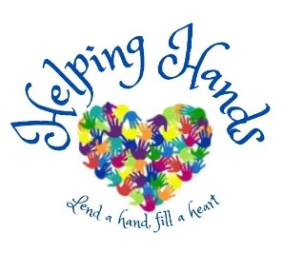
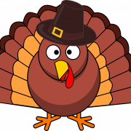
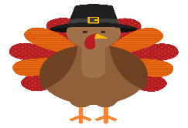
Thanksgiving Food Drive

Drop off Locations:
Your Name or team, troop, group here
Your Name or team, troop, group here

Grocery
- Baby Food
- Bag of Potatoes
- Bag Stuffing.
- Baked Beans, Kidney Beans, Etc.
- Biscuit or Roll Mix
- Bottle of Apple Cider
- CAKE MIX
- Canned Cranberry Sauce
- Canned Fruit, Juices, And Soups
- Canned Meats or Dinners
- Cans of Vegetables (Carrots, Peas, Potatoes, Etc.)
- Carnation Good Start Baby Formula
- Cereal
- Coffee / Tea / Sugar
- Cookies, Crackers, Snacks
- Grape Jelly and Peanut Butter
- Instant Potatoes, Rice, Or Pasta
- Jar of turkey gravy
- Jell-O Or Pudding
- Macaroni and Cheese
- MILK
- Mixes (Hamburger Helper, Etc.)
- Muffin, Biscuits, And Pancake Mixes
- Paper plates, napkins, cups
- Paper Products (Toilet Paper)
- PASTA
- PASTA SAUCE
- Personal Hygiene Products
- Pie Crust and pie filling
- Powdered Milk
- Prepared Tomato Sauce (Cans Only)
- Salt, pepper, herbs, spices
- Sugar, Ketchup, Mayo, Mustard, Salad Dressing, Cooking Oil
- SODA
- Tea, Instant Coffee, Hot Chocolate
- Tuna Fish
- Vegetables, (Potatoes, Yams, Onions, Squash, Carrots)

Home & Cleanliness
☐ Toilet paper, Paper Towels, Cleaners
☐ Can opener, stock pot, disposable aluminum trays, storage containers, Ziploc bags.
☐ Scissors, tweezers, nail clippers, razor
☐ 11/21 – Three days only TEXTILE donations- Holiday table linens, aprons, dish cloths, cloth napkins, towels, pot holder

Health & Hygiene
☐ Bars Of Soap, hand soap, Shampoo
☐ Diapers and Pull Ups, wipes, ointment, powder
☐ Razors, shaving cream
☐ Comb, brush, pic
☐ Socks & underwear
☐ Deodorant
☐ Feminine Hygiene products
☐ Towels, washcloths
☐ Powders, lotions, nail polish, nail polish remover
☐ Laundry Detergent (Regular Size) Laundry bags
☐ Travel-size packets of toiletries
☐ Antibiotic wipes, hydrogen peroxide, cotton balls
☐ Antiseptic cream

Perishable Items
☐ Turkey or Ham
☐ Milk, half and half, eggs, butter
☐ Desserts, apple pies, cookies**Fresh Turkey, Ham and perishable food donations to be delivered on November 16 or 23 for distribution to participant families.

